**NEUROMARKETING PLATFORM COMPARISON: A DEEP DIVE STUDY**

**1) INTRODUCTION**

Consumer Neuroscience or neuromarketing is a field that concerns the applications of neuroscience methods to better understand human manners related to marketing trades. First, it might seem strange that marketers would be interested in using neuroscience to understand consumer’s preferences. Design and presentation of products so that they are highly preferred with the consumers in terms of their preferences is usually the goals of every marketer. To understand consumers’ preferences, several standard research tools are commonly used by marketers, such as personal interviews with the consumers, scoring questionnaires gathered from consumers, and focus groups. The entire purpose of using brain imaging tools instead of simply asking people for their preferences is because people cannot (or do not want to) explain their reasons behind those preferences. It is seen that researchers in the field believe that brain imaging tools can provide access to vital information within the consumers brain during the origination of a learning or observation during a business promotion. The question whether this information would be useful in product promotion among the consumers is still in dispute in the marketing literature. It is hoped that these brain imaging techniques would provide efficient tradeoff between costs and benefits of research. At present, the neuroscience stratagem involves powerful brain imaging tools based on the gathering of hemodynamic or electromagnetic signals related to the human brain activity during the performance of a relevant task for marketing objectives.

Becker *et al*. (1964) describes that for each person there exist numerical constants, called utilities, associated with the various possible outcomes of his actions, given the external events not under his control. A typical consumer would always weigh their choices in terms of highest return based on the activities performed. This paper does not deal with probabilistic models that would be used to calculate subjects decisions based on the paradigm or activity they are supposed to perform but instead, we would delve into the usage of EEG signals in order to find results that impact a consumers decision in terms of procuring an item displayed on an ecommerce platform.

Electroencephalography (EEG) is one of them which is most widely used to examine the brain activity. Measurements of electrical activity that take place on the scalp is what we call Electroencephalogram (EEG). Ionic current flows within the neurons of the brain result in voltage changes which are measured in EEG. Below are 5 major frequencies with their different frequency bands (Figure 1). They range from low to high, beginning from Delta (1-3Hz), Theta (4-7Hz), Alpha (8-13Hz), Beta(14-30Hz) and Gamma(31-50Hz). The 10-20 system is an internationally recognized method to describe electrode placement which is shown below in Figure 2. Each position on the scalp has a letter to identify the lobe and a number to locate their hemisphere location.

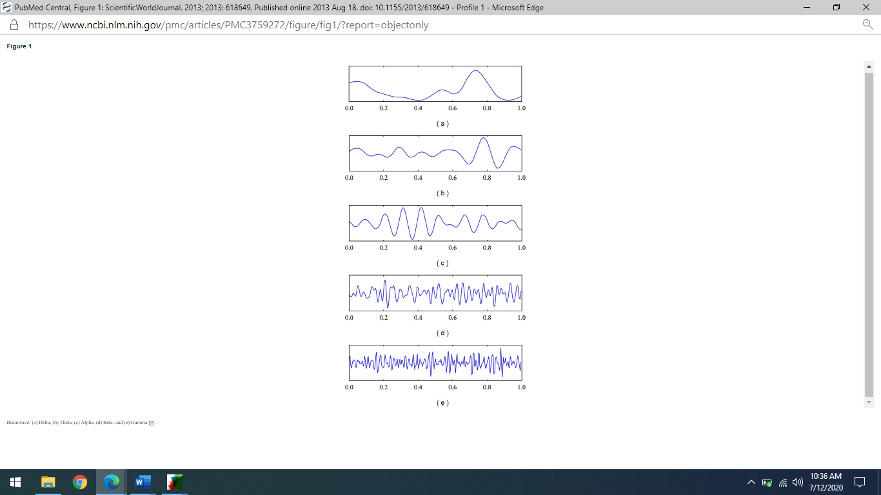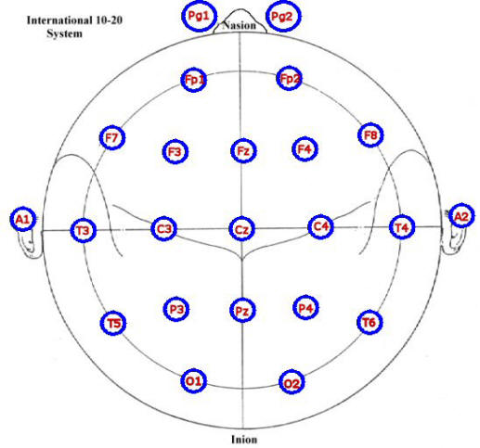

**Figure 1**

**Figure 2**

**2) METHODOLOGY**

**2.1) Subject and Experimental Paradigm**

6 healthy participants were invited to take part in the experiment, here termed as subject. The subjects belonged between the ages of 20-24. The subjects were selected from the Institute of Business Administration irrespective of their gender. In preparation for the experiment, it was made sure that the subjects had an idea of how the ecommerce platforms of AliExpress and Daraz functioned.

Prior to the actual EEG data acquisition, a written consent was also taken from the subject. A proper protocol regarding the data acquisition was first briefed to the subject and was initially trained to properly acquire brain data. During the experiment, the subject was advised to sit on an armchair in front of which a monitor screen was fixated. On the screen, a queue was displayed with fixed intervals in between that would reveal products which would be available on both the platforms. The paradigms would be shifted alternately to secure readings for both the experimental paradigms.

**2.2) Signal Processing**

The initial data was collected at the Physics Department in University of Karachi. The device that was used for the data collection is NeuroPro32 by MDX Instruments USA, combined with analytical software EEGLAB which is an extension of MATLAB. NeuroPro32 is a top tier product by MDX Instruments designed with ultra-sensitive sensors to measure the activity of the brain. Provides its user with the internationally recognized 10-20 electrode placement. Sampling speed for the data collection was set at 200Hz/sec with an Input impedance greater than or equal to 10MΩ.

**2.3) EEGLAB**

There were 2 trials generated per subject leading to a total of 12 trails. Each trial was pre processed by performing Average referencing and Filtering. A low pass filter of 0.5Hz along with a high pass filter of 40Hz was performed on the dataset to remove artifacts from the data. Taking a common average reference in the EEG data, also corresponds to taking a common average reference in the forward model. The consequence of subtracting the average potential (from each channel) is that the model error is averaged over all channels. Since there is no reason to assume that the model error is specifically positive or negative, the model error tends to average out and the forward solution at each channel will have a much smaller forward model error. Bad and Unwanted Channels were removed from the data before performing Power Spectrum Analysis as they would only interfere with the results leading to a contaminated outcome.

**3) Results**

Results obtained from the aforementioned methodology are discussed in this section. EEGLAB, a MATLAB assisted software that is designed to analyze data extracted from the subjects, is used to draw conclusions from the techniques used.

**3.1) Channel Activities**

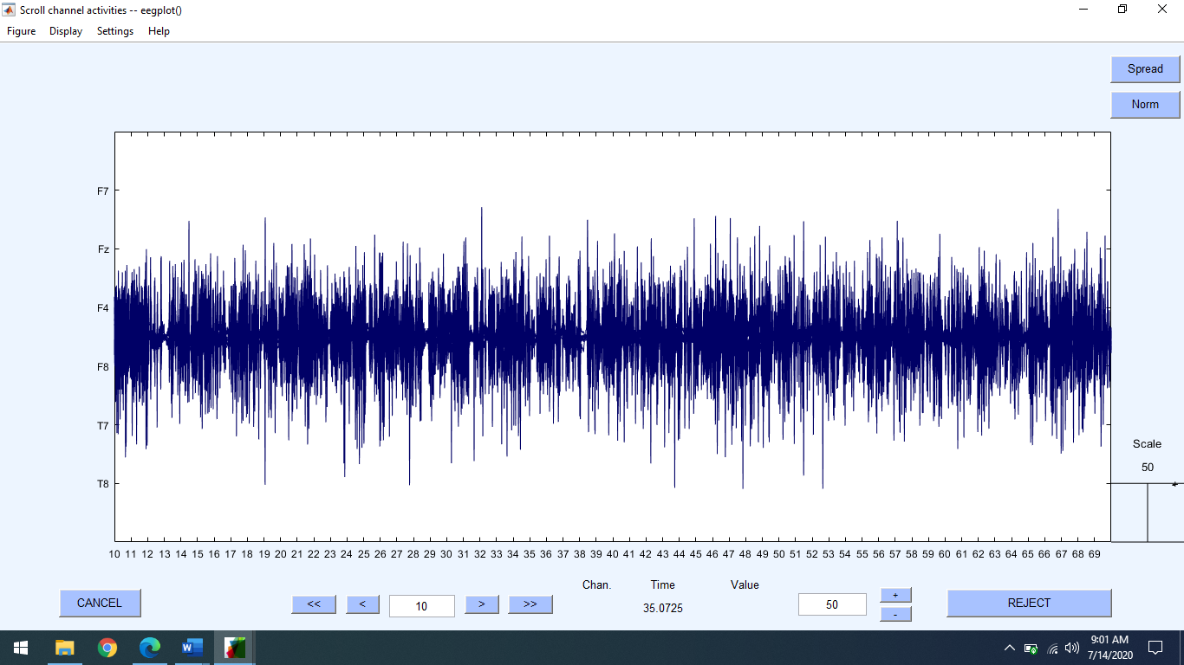Figure 3 below discusses the activity that took place over the remaining channels that were finalized after average referencing and removal of bad/unwanted channels.

**Figure 3**

The data shows that there was constant activity over F7, FZ, F4, F8, T7 and T8. There was constant activity over the respective channels and no artifact removal was required.

Fz – Represents frontal eye fields, motor, focus and action observation.

F4 – Represents contextual attention.

F7- Represents approach behavior, engagement, interest, mood regulation, processing of positive emotional input, conscious awareness. Frontal mirror neuron system – empathy and intention of others. Creates and controls output of spoken and written language, visual and auditory working memory, selective attention Broca’s area (word retrieval, semantics, verbal understanding, speech).

F8 – Represents avoidance behavior, withdrawal, impulse control (important links to the amygdala). Emotional tone variations (motor aprosodia). Spatial and visual working memory, gestalt, sustained attention, conscious facial emotional processing, prosody Empathy conscience. Feeling sense of right and wrong. Emotional gating. Vigilance area. Apprehension, disinterest Sustained and selective attention Processing of anger, rate, anxiety, fear. Regulation of aggressive and sexual impulses

T7 and T8 represent the mid temporal lobe which is extending into the hippocampal lobes.

**3.2) Results from EEGLAB - Power Spectrum Analysis**

Power spectral density function (PSD) shows the strength of the variations(energy) as a function of frequency. In other words, it shows at which frequencies variations are strong and at which frequencies variations are weak. The unit of PSD is energy (variance) per frequency(width) and you can obtain energy within a specific frequency range by integrating PSD within that frequency range.

PSD is a very useful tool if you want to know frequencies and amplitudes of oscillatory signals in your time series data. Figure 5 below, depicts the results of Power Spectrum Analysis performed on one trial.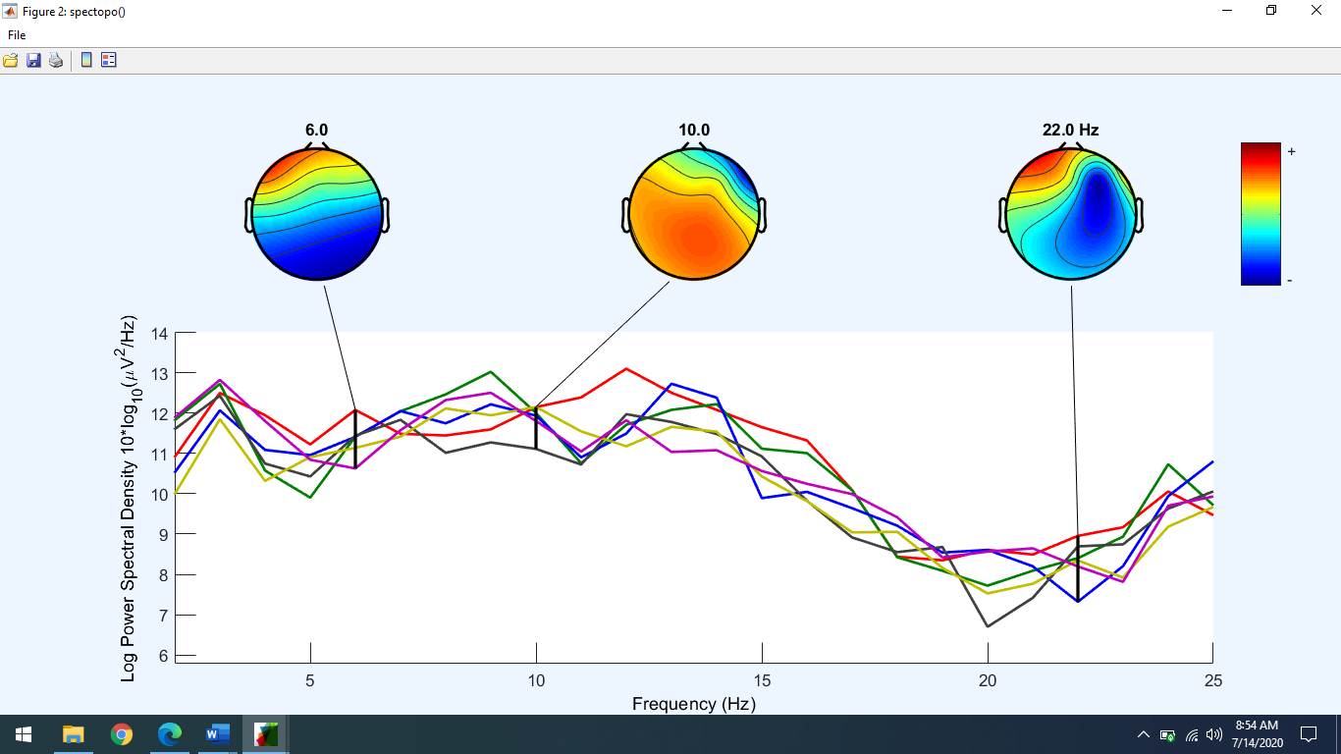

**Figure 4**

The same analysis was performed for all the trials that were gathered initially after average referencing and removal of bad/unwanted channels.

**4) DISCUSSION**

According to an FMRI study, when a subject is exposed to a brand logo, there is an increase of hyper oxygenated blood in the medial prefrontal cortex. Hyper oxygenated blood has different magnetic properties than deoxygenated blood. Variations in MRI images between control and test exposures allow the image interpreter to make assumptions about the relationship between exposure to the brand logo and the functions associated with the affected region of the brain. In this case, the medial prefrontal cortex was activated during exposure to a brand, suggesting self-involvement. Apparently, the brain is assessing the brand/logo icon to determine if it is of personal relevance or importance to the person. Higher levels of activation would suggest higher levels of involvement.

To the secure a deductive result, subjects were trained prior to the EEG data collection. One of the reasons behind this was because of the learning curve. The number of rehearsals for every activity impact the performance of building up memory of what to do. Each rehearsal leads to a stronger connection between the neurons, laying down sensitivities in the synapses which in return leads to a better quality of data received.

Brain’s response to short-term rewards usually occurs in the limbic system, Fugate (2008). The prefrontal cortex is usually associated with logical reasoning when considering future rewards but in situations where immediate gratification is being pondered upon then the limbic region will prevail above. This becomes applicable for short-term rewards connected with food, entertainment, etc. However, products that deliver long-term rewards such as insurance policies, medicines, etc. are not targeted by the limbic system, receiving low processing priority.

The amygdala usually operates in a way where immediate results are generated. The reptilian sector of the lower brain is responsible for processing situations where immediate positive feedback or output is probable. Situations where binary decisions along with quick results are involved are handled by the amygdala which means less logical reasoning and a decision based on a simple good or bad.

On the other hand, the hippocampus provides a much more subtle response that does interpret the nuances, but it takes longer to do so, which is why the amygdalal reaction kicks in first. The hippocampus is the region where most of the rational details are analyzed provided by the neuronal Gestalt.

The data represents that there has been activity over the pre-frontal cortex along with the limbic region. Based on the literature reading, the temporal nodes are responsible for collecting data over the limbic region whereas the prefrontal and frontal nodes are not only responsible for establishing goals and decisions but also have neurons leading to the amygdala.

Prefrontal lobes are responsible for executive functioning, planning and process and working memory. More importantly, prefrontal lobes have neuronal network connections to the amygdala which means that they are activating the limbic region. Self-regulation, initiation, social-emotional behavior in 3 social context, recognition, and production of expression of language (prosody) are all major functions of the prefrontal lobe. Decrease in left prefrontal activation may reflect depressive experience where increase in right prefrontal activation may reflect anxieties.

As it was mentioned above that F7, FZ, F4 and F8 were a part of frontal and prefrontal cortex which allows us to make a deductive reasoning that not only are both the cortexes responsible for making decisions, processing visual context and much more but they are also linked with the amygdala. The brain is not just a cognitive processing organism; it is also the seat of our conscience. Emotions, morals, and social self cannot be isolated to frontal lobe activities; other deeper structures are also involved. There is a relationship between the frontal lobe and the amygdala. The frontal cortex is responsible for the brains most complex processing and has the heaviest projections to the amygdala, and the two combine to form a network that is the social brain.

PSD presented in the Section 3.2 enlightens us with the fact that the data contains a mixture of Alpha, Theta and Beta frequencies. Alpha frequencies lie in the range of 8-12Hz are slower and larger. Alpha is generated from resonance between the thalamus and the cortex. They are generally associated with a state of relaxation, peacefulness, and alertness. Activity in the lower half of this range represents to a considerable degree the brain shifting into an idling gear, relaxed and a bit disengaged, waiting to respond when needed. If people merely close their eyes and begin picturing something peaceful, in less than half a minute there begins to be an increase in alpha brainwaves. These brainwaves are especially large in the back third of the head. EEG investigations of alcoholics (and the children of alcoholics) have documented that even after prolonged periods of abstinence, they frequently have lower levels of alpha and theta brainwaves and an excess of fast beta activity. Alpha waves will peak around 10 Hz. Good healthy alpha production promotes mental resourcefulness, aids in the ability to coordinate mentally, enhances overall sense of relaxation and fatigue. In this state you can move quickly and efficiently to accomplish whatever task is at hand. When Alpha predominates most people feel at ease and calm. Alpha appears to bridge the conscious to the subconscious. Alpha rhythms are reported to be derived from the white matter of the brain. The white matter can be considered the part of the brain that connects all parts with each other. A short duration of Theta wave(4-8Hz) represents a state of calmness. Theta is generated through the thalamo-cortical path and reflects resources used in the body, pulled into the brain when needed. Beta brainwaves are small, relatively fast brainwaves (above 13–30 Hz) associated with a state of thinking, mental, intellectual activity, and outwardly focused sustained concentration. High Beta (above 18 Hz) means muscle artifact can intrude here. The subject tends to inhibit high beta to decrease artifact. Subjective feeling states include alertness, agitation, problem solving, 15 anxiety, worrying, rumination, mental effort. Associated tasks & behaviors include mental activity, e.g. math, planning, etc. Physiological correlates: general activation of mind & body functions.

Due to equipment constraints we could not finalize whether it was from the Amygdala or the Hippocampus but based on the literature reading, it could be said that the paradigm triggered the limbic system to gain its attention in terms of data collection.

**5) Conclusion**

At this point, neuromarketing is mostly a set of intriguing but far from conclusive experiments linking internal brain activity with external behaviors. For this field of study to become legitimized, it would be necessary to construct a behavioral model that would predict what types of consumption related problems that brain structures under study need to solve. Second, there would need to be experimental methods which measure the contribution of each brain structure to the overall decision. Once this task is concluded, the model could be operationalized by determining which stimuli (marketing inputs) provide the appropriate brain structure with the material it needs to accomplish its assigned task. Such a model appears to be far in the future at this point although some preliminary conceptualization of neuroscience and the broader field of marketing science are explored by Lee et al. (2007). More to the present, what can or what should we do with the knowledge gained so far? It is strategically risky to ignore a promising new science, even worse to accept it without question. The following recommendations are offered in no order of importance: First, Grimes (2006) makes a very good argument that it is difficult to create classification schemes for marketing stimuli that are specific, mutually exclusive and exhaustive. A stimulus such as a word can processed for visual (STOP) value, simple linguistic value (stop); generate varying degree of interest (STOP); be of high or low involvement ( ); have emotional or connotative meanings (STOP!), and so forth depending on the person. Each stimulus would likely produce a different result depending on which neural networks were activated. In other words, marketers and researchers would have great difficulty translating narrowly defined scientific findings into broadly applicable tools and frameworks. Future work in the area of neuromarketing, to be fruitful and to lay the groundwork for the model outlined above, should attempt to find “universal” stimulus classification systems that are generalizable to a broad population or at least a viable target market. Otherwise, the interactive nature of brain function will likely result in widely differing responses and eventual behavior vis-a-vis any stimulus and audience. The opposing position, customizing each stimulus package for each individual consumer to ensure predictability of brain response, is highly impractical. Second, the inflammatory rhetoric from marketing critics is not helpful and, in some respects, it is counterproductive. Firms that are using neuromarketing, even in an experimental fashion, should be very forthcoming with their experiments and results. Demonstrating that neuromarketing is not incompatible with consumer interests, e.g. might reduce unnecessary promotional/product development spending, etc.; would be a beginning. Also, effectively demonstrating that consumers might learn more about themselves as it relates to decision making would be helpful. In effect, they, as consumers, can apply the controls needed to curb unhealthy consumer behaviors such as overspending, impulse shopping, and unhealthy eating habits (i.e. some of the current complaints). As a corollary, neuro-based models will better inform policymakers and lead to more intelligent policies and legislation. Third, marketing researchers should use neuroimaging to confirm, reconfigure, or improve our conventional theories of consumer behavior. Basic assumptions about the role of trust, risk taking, personality traits, consumer satisfaction, brand loyalty, and dozens of other “standards” of the marketing literature can be corroborated in a very physical way with brain imaging techniques. Such validation efforts might not be conclusive, but it is likely that at least some strengths and shortcomings will be discovered. With each discovery comes the opportunity for correction and improvements in marketing management decisions. With confirmation comes more confidence that our current understanding of consumer behavior is a useful basis for creating exchange relationships. Four, future neural research efforts are likely to result in more, not less, complexity and ambiguity. As the mind is probed more deeply, simplistic – or at least causal – explanations of arousal and market behavior are likely to become even rarer. Neurological science envisions therapies for brain trauma, genetic defects or perhaps treatment for mental disease. If marketing wishes to benefit from the advances of neuroscience, we should shift part of the neural science focus to applied research in marketing. This likely means funding, legitimization of the effort by bodies such as the American Marketing Association (AMA), Association for Consumer Research (ACR), or the Marketing Science Institute (MSI); and a willingness of the marketing community to give this effort time to produce useful results.

**6)** **References**

Grimes, A. (2006). Are We Listening and Learning? Understanding the Nature of Hemispherical Lateralisation and its Application to Marketing. International Journal Of Market Research, 48(4), 439-458. doi: 10.1177/147078530604800406

Bettman, J., & Zins, M. (1977). Constructive Processes in Consumer Choice. Journal Of Consumer Research, 4(2), 75. doi: 10.1086/208682

Mitani, Y., Kubo, T., Chiba, Y., Maruyama, Y., Moriya, K., & Nakagawa, M. (2019). Brain Activity During Listening to And Imagining Music: Does Imagining Music Provide a Similar Effect as Listening to Music?. *Journal Of The Institute Of Industrial Applications Engineers*, *7*(4), 127-131. doi: 10.12792/jiiae.7.127

Daly, I., Williams, D., Hwang, F., Kirke, A., Miranda, E., & Nasuto, S. (2019). Electroencephalography reflects the activity of sub-cortical brain regions during approach-withdrawal behaviour while listening to music. *Scientific Reports*, *9*(1). doi: 10.1038/s41598-019-45105-2

Wu, C., Gu, H., Lu, H., Stein, E., Chen, J., & Yang, Y. (2008). Frequency specificity of functional connectivity in brain networks. *Neuroimage*, *42*(3), 1047-1055. doi: 10.1016/j.neuroimage.2008.05.035

Goto, N., Mushtaq, F., Shee, D., Lim, X., Mortazavi, M., Watabe, M., & Schaefer, A. (2017). Neural signals of selective attention are modulated by subjective preferences and buying decisions in a virtual shopping task. *Biological Psychology*, *128*, 11-20. doi: 10.1016/j.biopsycho.2017.06.004

Hubel, D., & Wiesel, T. (1965). RECEPTIVE FIELDS AND FUNCTIONAL ARCHITECTURE IN TWO NONSTRIATE VISUAL AREAS (18 AND 19) OF THE CAT. *Journal Of Neurophysiology*, *28*(2), 229-289. doi: 10.1152/jn.1965.28.2.229

Hubert, M., & Kenning, P. (2008). A current overview of consumer neuroscience. *Journal Of Consumer Behaviour*, *7*(4-5), 272-292. doi: 10.1002/cb.251

Javor, A., Koller, M., Lee, N., Chamberlain, L., & Ransmayr, G. (2013). Neuromarketing and consumer neuroscience: contributions to neurology. *BMC Neurology*, *13*(1). doi: 10.1186/1471-2377-13-13

Lee, N., Broderick, A., & Chamberlain, L. (2007). What is ‘neuromarketing’? A discussion and agenda for future research. *International Journal Of Psychophysiology*, *63*(2), 199-204. doi: 10.1016/j.ijpsycho.2006.03.007

Devinsky, O. (1998). The Temporal Lobe and Limbic System. *Archives of Neurology*, *55*(4),  
574-a-575. <https://doi.org/10.1001/archneur.55.4.574-a>

Lin, C.-H., Tuan, H.-P., & Chiu, Y.-C. (2011). “Medial frontal activity in brand-loyal consumers: A behavioral and near-infrared ray study”: Correction to Lin, Tuan, and Chiu (2010). *Journal of Neuroscience, Psychology, and Economics*, *4*(1), iv–v. <https://doi.org/10.1037/a0022462>

Muñoz-Gutiérrez, P. A., Giraldo, E., Bueno-López, M., & Molinas, M. (2018). Localization of Active Brain Sources From EEG Signals Using Empirical Mode Decomposition: A Comparative Study. *Frontiers in Integrative Neuroscience*, *12*. <https://doi.org/10.3389/fnint.2018.00055>

Knutson, B., Rick, S., Wimmer, G. E., Prelec, D., & Loewenstein, G. (2007). Neural Predictors of Purchases. *Neuron*, *53*(1), 147–156. <https://doi.org/10.1016/j.neuron.2006.11.010>

Dimoka, A., Pavlou, P. A., & Davis, F. D. (2011). Research Commentary—NeuroIS: The Potential of Cognitive Neuroscience for Information Systems Research. *Information Systems Research*, *22*(4), 687–702. https://doi.org/10.1287/isre.1100.0284

‌Erik Du Plessis. (2012). The advertised mind : groundbreaking insights into how our brains respond to advertising. London ; Philadelphia: Kogan Page.

‌Gunbey, H. P., Ercan, K., Fındıkoglu, A. S., Bulut, H. T., Karaoglanoglu, M., & Arslan, H. (2014). The Limbic Degradation of Aging Brain: A Quantitative Analysis with Diffusion Tensor Imaging. *The Scientific World Journal*, *2014*, 1–7. <https://doi.org/10.1155/2014/196513>

Vecchiato, G., Wanzeng Kong, Maglione, A. G., & Daming Wei. (2012). Understanding the Impact of TV Commercials: Electrical Neuroimaging. *IEEE Pulse*, *3*(3), 42–47. <https://doi.org/10.1109/mpul.2012.2189171>

Dimoka. (2010). What Does the Brain Tell Us About Trust and Distrust? Evidence from a Functional Neuroimaging Study. *MIS Quarterly*, *34*(2), 373. https://doi.org/10.2307/20721433

‌ Cha, K. C., Suh, M., Kwon, G., Yang, S., & Lee, E. J. (2019). Young consumers’ brain responses to pop music on Youtube. *Asia Pacific Journal of Marketing and Logistics*, *ahead*-*of*-*print*(ahead-of-print). <https://doi.org/10.1108/apjml-04-2019-0247>

Brannon, L. A., & Kannan, S. (2004). How customers think: essential insights into the mind of the market. Gerald Zaltman. Harvard Business School Press, Boston, MA, 2003. No. of pages 368. ISBN 1-57851-826-1. Price $29.95. *Applied Cognitive Psychology*, *18*(7), 939–940. <https://doi.org/10.1002/acp.1056>

Muñoz-Leiva, F., & Gómez-Carmona, D. (2019). Sparking interest in restaurant dishes? Cognitive and affective processes underlying dish design and ecological origin. An fMRI study. *Physiology & Behavior*, *200*, 116–129. https://doi.org/10.1016/j.physbeh.2018.06.017

‌

‌

‌

‌

‌

‌

‌

‌

‌